-----------------------------------------------------------
-- 1. CREATE DATABASE
-----------------------------------------------------------

IF DB_ID('RaceDayDB') IS NULL
BEGIN
CREATE DATABASE RaceDayDB;
END
GO

USE RaceDayDB;
GO

-----------------------------------------------------------
-- 2. REMOVE EXISTING TABLES
-- This allows the script to be tested again.
-----------------------------------------------------------

IF OBJECT_ID('dbo.Results', 'U') IS NOT NULL
DROP TABLE dbo.Results;
GO

IF OBJECT_ID('dbo.Enrolments', 'U') IS NOT NULL
DROP TABLE dbo.Enrolments;
GO

IF OBJECT_ID('dbo.EventCategories', 'U') IS NOT NULL
DROP TABLE dbo.EventCategories;
GO

IF OBJECT_ID('dbo.Categories', 'U') IS NOT NULL
DROP TABLE dbo.Categories;
GO

IF OBJECT_ID('dbo.Events', 'U') IS NOT NULL
DROP TABLE dbo.Events;
GO

IF OBJECT_ID('dbo.Users', 'U') IS NOT NULL
DROP TABLE dbo.Users;
GO

-----------------------------------------------------------
-- 3. CREATE USERS TABLE
-----------------------------------------------------------
-- Stores both Organizers and Participants.
-----------------------------------------------------------

CREATE TABLE Users
(
UserId INT IDENTITY(1,1)
CONSTRAINT PK_Users PRIMARY KEY,

FirstName NVARCHAR(50) NOT NULL,

LastName NVARCHAR(50) NOT NULL,

Email NVARCHAR(255) NOT NULL
CONSTRAINT UQ_Users_Email UNIQUE,

PasswordHash NVARCHAR(255) NOT NULL,

Role VARCHAR(20) NOT NULL,

Phone NVARCHAR(20) NULL,

CreatedAt DATETIME2 NOT NULL
CONSTRAINT DF_Users_CreatedAt DEFAULT SYSDATETIME(),

CONSTRAINT CK_Users_Role
CHECK (Role IN ('Organizer', 'Participant'))
);
GO
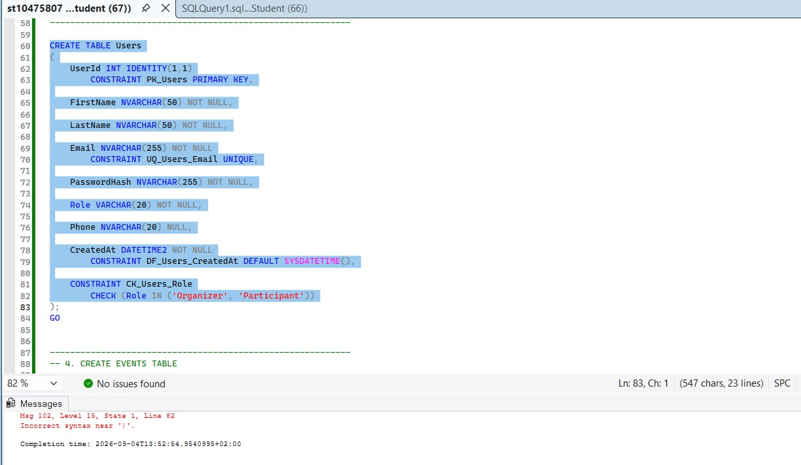

-----------------------------------------------------------
-- 4. CREATE EVENTS TABLE
-----------------------------------------------------------
-- Each event belongs to one Organizer.
-----------------------------------------------------------

CREATE TABLE Events
(
EventId INT IDENTITY(1,1)
CONSTRAINT PK_Events PRIMARY KEY,

OrganizerId INT NOT NULL,

EventName NVARCHAR(150) NOT NULL,

Description NVARCHAR(500) NULL,

EventDate DATE NOT NULL,

Location NVARCHAR(200) NOT NULL,

Status VARCHAR(20) NOT NULL
CONSTRAINT DF_Events_Status DEFAULT 'Open',

CreatedAt DATETIME2 NOT NULL
CONSTRAINT DF_Events_CreatedAt DEFAULT SYSDATETIME(),

CONSTRAINT FK_Events_Organizer
FOREIGN KEY (OrganizerId)
REFERENCES Users(UserId),

CONSTRAINT CK_Events_Status
CHECK (Status IN
('Draft', 'Open', 'Closed', 'Completed'))
);
GO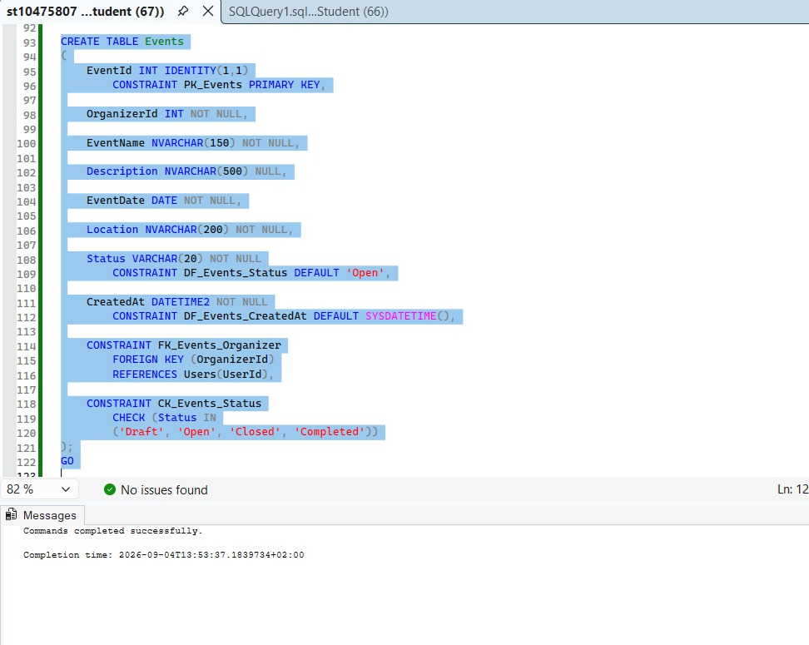

-----------------------------------------------------------
-- 5. CREATE CATEGORIES TABLE
-----------------------------------------------------------
-- Stores reusable race categories.
-----------------------------------------------------------

CREATE TABLE Categories
(
CategoryId INT IDENTITY(1,1)
CONSTRAINT PK_Categories PRIMARY KEY,

CategoryName NVARCHAR(100) NOT NULL
CONSTRAINT UQ_Categories_Name UNIQUE,

Description NVARCHAR(300) NULL,

DistanceKm DECIMAL(6,2) NULL,

CONSTRAINT CK_Categories_Distance
CHECK (DistanceKm IS NULL OR DistanceKm > 0)
);
GO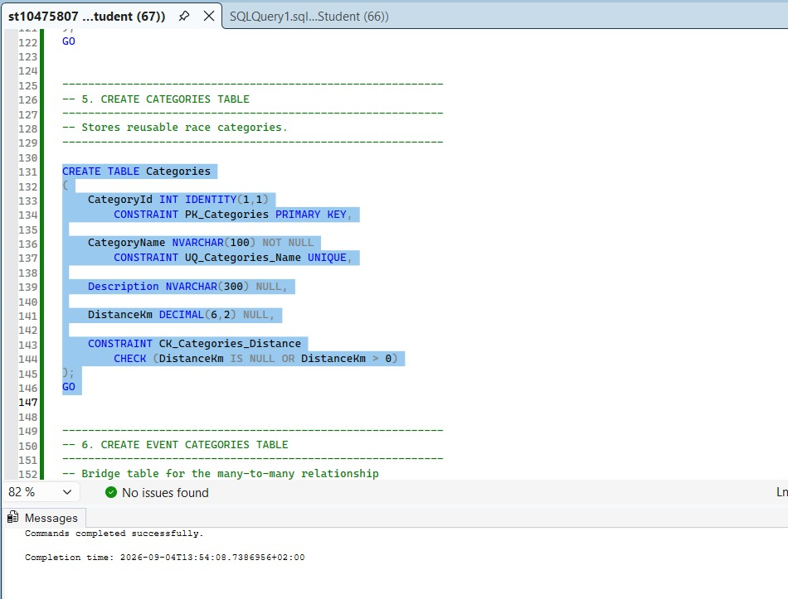

-----------------------------------------------------------
-- 6. CREATE EVENT CATEGORIES TABLE
-----------------------------------------------------------
-- Bridge table for the many-to-many relationship
-- between Events and Categories.
-----------------------------------------------------------

CREATE TABLE EventCategories
(
EventId INT NOT NULL,

CategoryId INT NOT NULL,

MaxParticipants INT NOT NULL
CONSTRAINT DF_EventCategories_MaxParticipants
DEFAULT 100,

EntryFee DECIMAL(10,2) NOT NULL
CONSTRAINT DF_EventCategories_EntryFee
DEFAULT 0.00,

CONSTRAINT PK_EventCategories
PRIMARY KEY (EventId, CategoryId),

CONSTRAINT FK_EventCategories_Event
FOREIGN KEY (EventId)
REFERENCES Events(EventId),

CONSTRAINT FK_EventCategories_Category
FOREIGN KEY (CategoryId)
REFERENCES Categories(CategoryId),

CONSTRAINT CK_EventCategories_MaxParticipants
CHECK (MaxParticipants > 0),

CONSTRAINT CK_EventCategories_EntryFee
CHECK (EntryFee >= 0)
);
GO
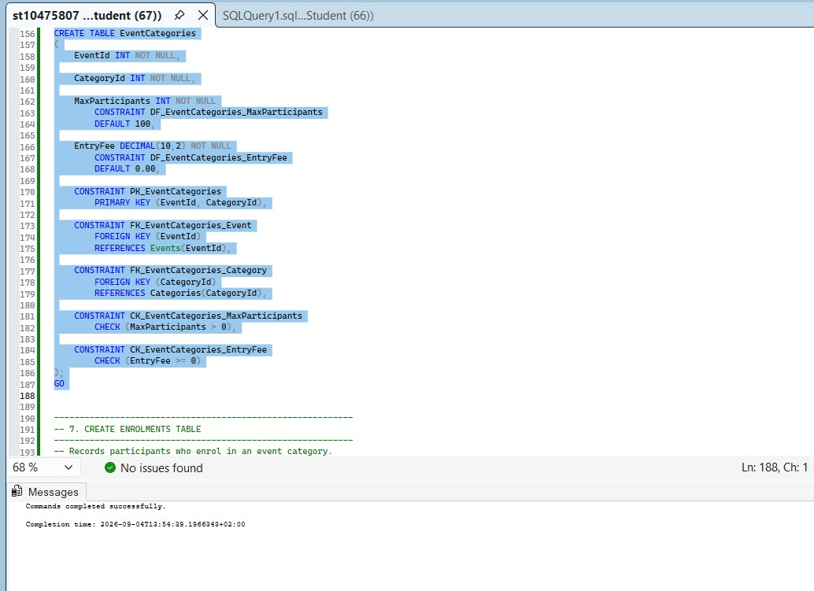

-----------------------------------------------------------
-- 7. CREATE ENROLMENTS TABLE
-----------------------------------------------------------
-- Records participants who enrol in an event category.
-----------------------------------------------------------

CREATE TABLE Enrolments
(
EnrolmentId INT IDENTITY(1,1)
CONSTRAINT PK_Enrolments PRIMARY KEY,

EventId INT NOT NULL,

CategoryId INT NOT NULL,

ParticipantId INT NOT NULL,

EnrolmentDate DATETIME2 NOT NULL
CONSTRAINT DF_Enrolments_Date
DEFAULT SYSDATETIME(),

Status VARCHAR(20) NOT NULL
CONSTRAINT DF_Enrolments_Status
DEFAULT 'Active',

CONSTRAINT FK_Enrolments_EventCategory
FOREIGN KEY (EventId, CategoryId)
REFERENCES EventCategories(EventId, CategoryId),

CONSTRAINT FK_Enrolments_Participant
FOREIGN KEY (ParticipantId)
REFERENCES Users(UserId),

CONSTRAINT UQ_Enrolments_ParticipantEventCategory
UNIQUE (ParticipantId, EventId, CategoryId),

CONSTRAINT CK_Enrolments_Status
CHECK (Status IN
('Active', 'Cancelled', 'Completed'))
);
GO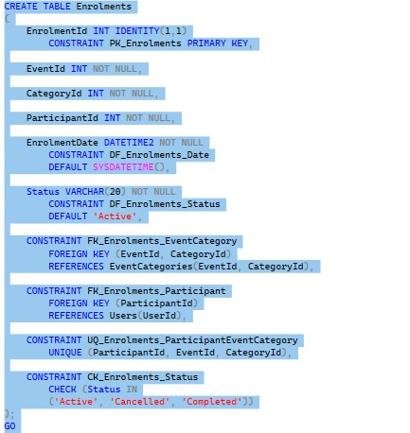

-----------------------------------------------------------
-- 8. CREATE RESULTS TABLE
-----------------------------------------------------------
-- Stores the result achieved by a participant.
-----------------------------------------------------------

CREATE TABLE Results
(
ResultId INT IDENTITY(1,1)
CONSTRAINT PK_Results PRIMARY KEY,

EnrolmentId INT NOT NULL
CONSTRAINT UQ_Results_Enrolment UNIQUE,

FinishPosition INT NULL,

FinishTime TIME(0) NULL,

ResultStatus VARCHAR(20) NOT NULL
CONSTRAINT DF_Results_Status
DEFAULT 'Pending',

RecordedAt DATETIME2 NOT NULL
CONSTRAINT DF_Results_RecordedAt
DEFAULT SYSDATETIME(),

CONSTRAINT FK_Results_Enrolment
FOREIGN KEY (EnrolmentId)
REFERENCES Enrolments(EnrolmentId),

CONSTRAINT CK_Results_Position
CHECK (FinishPosition IS NULL OR FinishPosition > 0),

CONSTRAINT CK_Results_Status
CHECK (ResultStatus IN
('Pending', 'Finished', 'DNF', 'DNS'))
);
GO
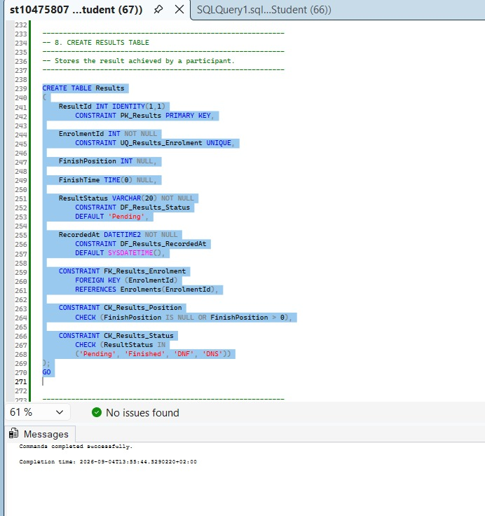

-----------------------------------------------------------
-- 9. INSERT TWO ORGANIZERS
-----------------------------------------------------------

INSERT INTO Users
(
FirstName,
LastName,
Email,
PasswordHash,
Role,
Phone
)
VALUES
(
'Thabo',
'Mokoena',
'thabo.organizer@raceday.co.za',
'DEMO_HASH_THABO',
'Organizer',
'0710000001'
),
(
'Lerato',
'Molefe',
'lerato.organizer@raceday.co.za',
'DEMO_HASH_LERATO',
'Organizer',
'0710000002'
);
GO

-----------------------------------------------------------
-- 10. INSERT TWO PARTICIPANTS
-----------------------------------------------------------

INSERT INTO Users
(
FirstName,
LastName,
Email,
PasswordHash,
Role,
Phone
)
VALUES
(
'Sipho',
'Ndlovu',
'sipho.participant@raceday.co.za',
'DEMO_HASH_SIPHO',
'Participant',
'0710000003'
),
(
'Amara',
'Mabena',
'amara.participant@raceday.co.za',
'DEMO_HASH_AMARA',
'Participant',
'0710000004'
);
GO

-----------------------------------------------------------
-- 11. INSERT RACE CATEGORIES
-----------------------------------------------------------

INSERT INTO Categories
(
CategoryName,
Description,
DistanceKm
)
VALUES
(
'5K Fun Run',
'Short community running event suitable for all levels.',
5.00
),
(
'10K Road Race',
'Competitive 10 kilometre road race.',
10.00
),
(
'Half Marathon',
'21.1 kilometre endurance race.',
21.10
),
(
'Trail Run',
'Off-road running category.',
15.00
);
GO

-----------------------------------------------------------
-- 12. INSERT THREE EVENTS
-----------------------------------------------------------

INSERT INTO Events
(
OrganizerId,
EventName,
Description,
EventDate,
Location,
Status
)
VALUES
(
1,
'Polokwane Spring Run',
'Annual road running event.',
'2026-10-10',
'Polokwane Sports Grounds',
'Open'
),
(
2,
'Louis Trichardt Mountain Challenge',
'Road and trail race around Louis Trichardt.',
'2026-11-07',
'Louis Trichardt Sports Complex',
'Open'
),
(
1,
'Limpopo Community Race Day',
'Community race supporting local sports development.',
'2026-12-05',
'Makhado Stadium',
'Draft'
);
GO

-----------------------------------------------------------
-- 13. ASSIGN CATEGORIES TO EVENTS
-----------------------------------------------------------

INSERT INTO EventCategories
(
EventId,
CategoryId,
MaxParticipants,
EntryFee
)
VALUES
(
1,
1,
300,
80.00
),
(
1,
2,
250,
120.00
),
(
1,
3,
150,
200.00
),
(
2,
1,
200,
80.00
),
(
2,
4,
180,
150.00
),
(
3,
1,
250,
60.00
),
(
3,
2,
200,
100.00
);
GO

-----------------------------------------------------------
-- 14. INSERT SAMPLE ENROLMENTS
-----------------------------------------------------------

INSERT INTO Enrolments
(
EventId,
CategoryId,
ParticipantId,
Status
)
VALUES
(
1,
1,
3,
'Active'
),
(
1,
2,
4,
'Active'
),
(
2,
4,
3,
'Active'
),
(
3,
1,
4,
'Completed'
);
GO

-----------------------------------------------------------
-- 15. INSERT SAMPLE RESULT
-----------------------------------------------------------

INSERT INTO Results
(
EnrolmentId,
FinishPosition,
FinishTime,
ResultStatus
)
VALUES
(
4,
12,
'00:29:45',
'Finished'
);
GO

-----------------------------------------------------------
-- 16. DISPLAY DATABASE DATA
-- Use these queries during your SSMS demonstration.
-----------------------------------------------------------

SELECT *
FROM Users;
GO
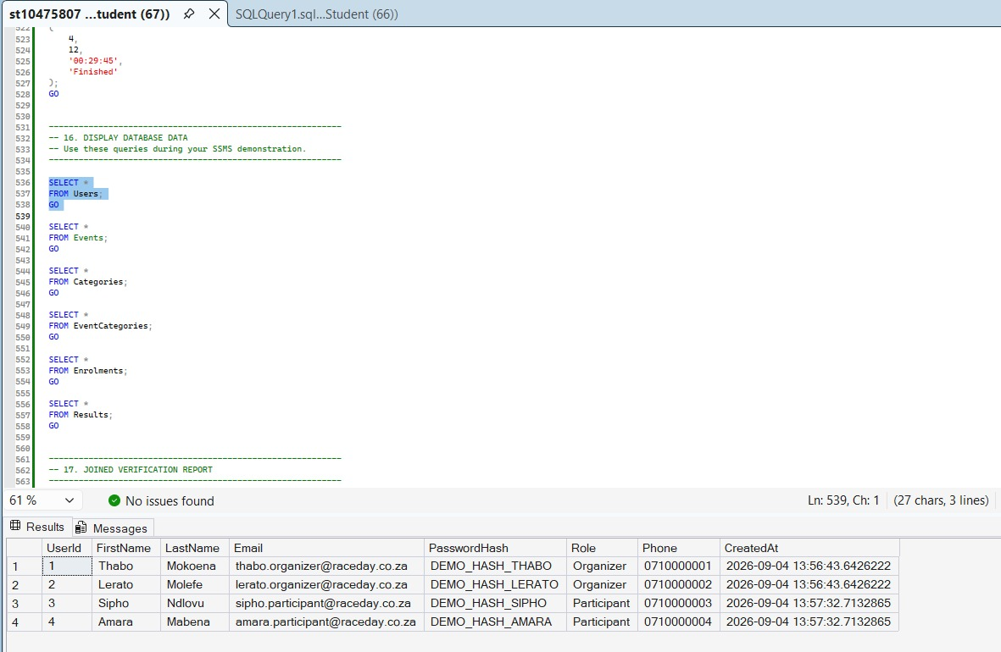

SELECT *
FROM Events;
GO

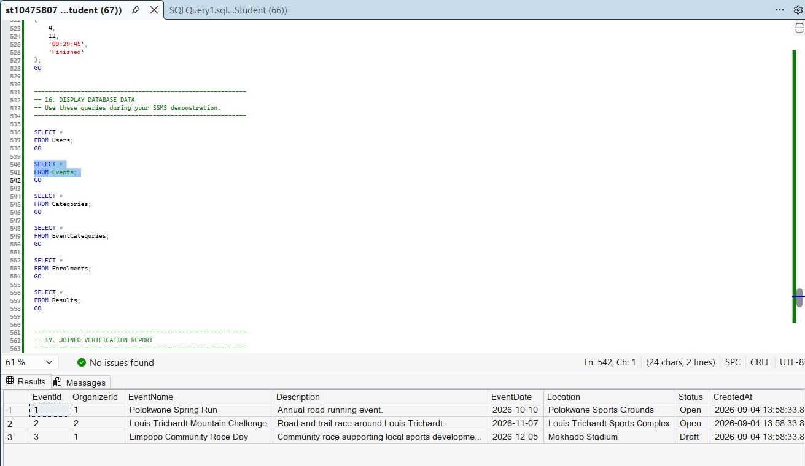
SELECT *
FROM Categories;
GO
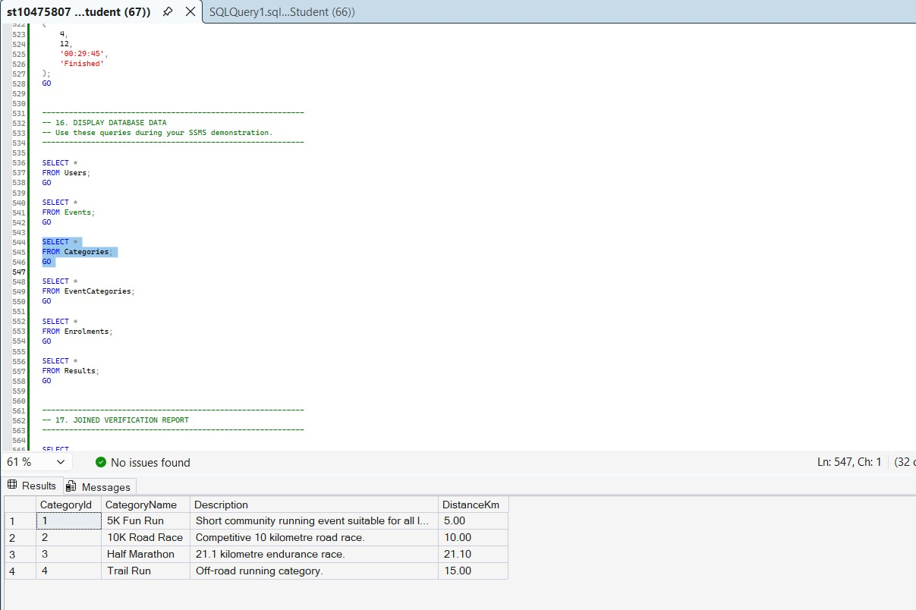

SELECT *
FROM EventCategories;
GO
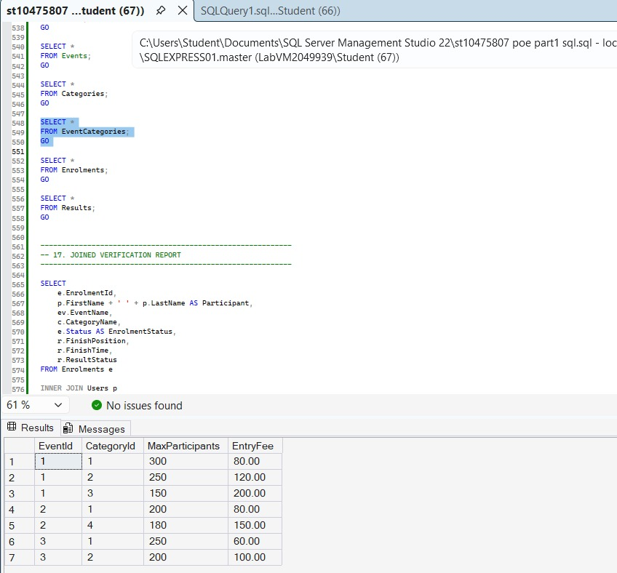

SELECT *
FROM Enrolments;
GO

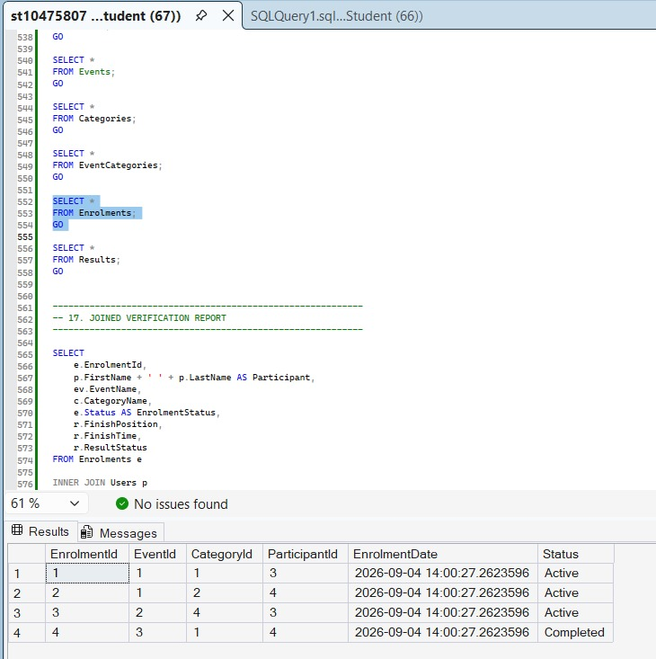
SELECT *
FROM Results;
GO

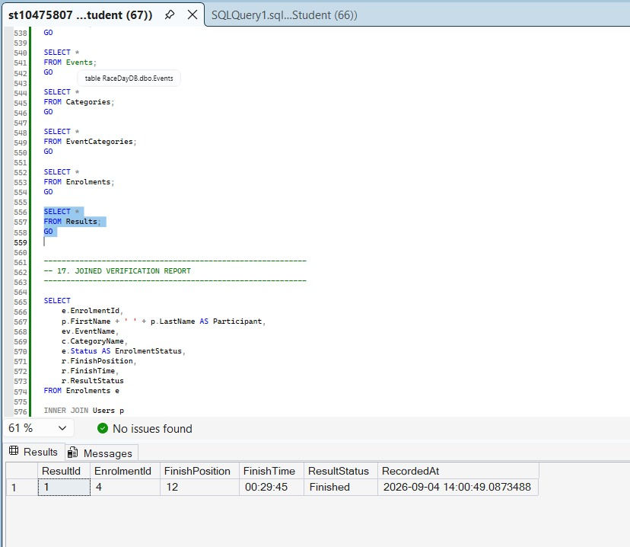

-----------------------------------------------------------
-- 17. JOINED VERIFICATION REPORT
-----------------------------------------------------------

SELECT
e.EnrolmentId,
p.FirstName + ' ' + p.LastName AS Participant,
ev.EventName,
c.CategoryName,
e.Status AS EnrolmentStatus,
r.FinishPosition,
r.FinishTime,
r.ResultStatus
FROM Enrolments e

INNER JOIN Users p
ON e.ParticipantId = p.UserId

INNER JOIN Events ev
ON e.EventId = ev.EventId

INNER JOIN Categories c
ON e.CategoryId = c.CategoryId

LEFT JOIN Results r
ON e.EnrolmentId = r.EnrolmentId

ORDER BY e.EnrolmentId;
GO
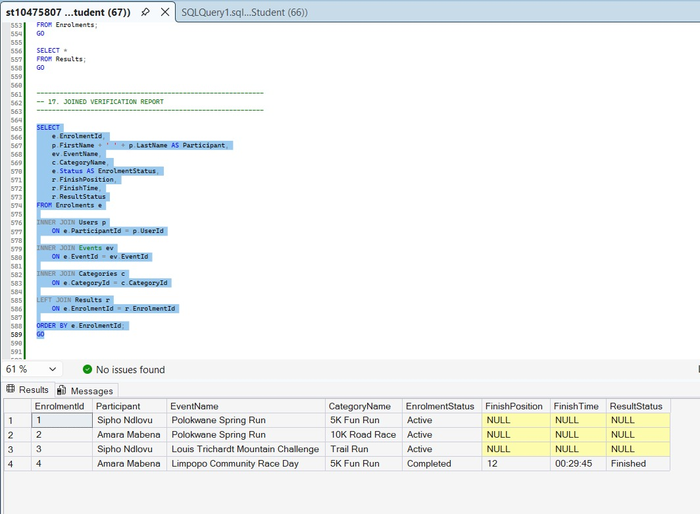

-----------------------------------------------------------
-- END OF RACEDAY DATABASE SCRIPT
-----------------------------------------------------------

